Name: _______________________ Class: __________ Date: _______
Instructions: Write answers in the right-hand column. Score: ___________ / 47 marks

Section A—Multiple choice (10 marks)

 | Which one of the following statements is INCORRECT?  A Liquids and gases are both fluids and they can be poured.  B Solids and liquids have a definite volume but gases have a variable volume.  C Solids are incompressible but liquids and gases are highly compressible.  D Solids have a definite shape, but liquids and gases have variable shapes. |  | 1
 | A gas is confined in a cylinder with a movable piston at one end. Assuming the temperature remains constant, if the piston is pushed in, which of the following statements about the volume and pressure of the gas is correct?  A The pressure will remain unchanged.  B The pressure will increase because the volume is increasing.  C The pressure will decrease due to the increase in volume.  D Because of the decrease in volume, the pressure will increase. |  | 1
 | A flask contains equal masses of two gases, hydrogen and nitrogen, at a temperature of 30⁰C. Which of the following statements about these gases is NOT correct?  A The average kinetic energy (½mv²) of the molecules of both gases is the same.  B The average velocity of the H₂ molecules is greater than the average velocity of the N₂ molecules.  C There are more H₂ molecules than N₂ molecules in the flask.  D The pressure exerted by the H₂ molecules in the flask is less than the pressure exerted by the N₂ molecules. |  | 1
 | Increasing the volume of a given amount of gas at a constant temperature causes the pressure to decrease because:  A the molecules are striking a larger area with the same force.  B there are fewer molecules.  C the molecules are moving more slowly.  D the molecules are hitting the wall with a smaller force. |  | 1
 | Which of the following liquids has the highest vapour pressure?  A pure water at 20⁰C  B sea water at 40⁰C  C pure water at 40⁰C  D ethanol (boiling point 78⁰C) at 40⁰C. |  | 1
 | Which one of the following statements is true?  The temperature at which ethanol boils:  A gradually increases as the ethanol boils away  B depends on room temperature  C decreases if the atmospheric pressure falls  D decreases if a small amount of water is added to it. |  | 1
 | Which of the following statements about solutions are true?  i When sodium chloride is dissolved in water, the water is the solute.  ii An unsaturated solution contains more solute than is needed to saturate it.  iii A supersaturated solution contains less dissolved solid per unit volume than a saturated solution.  iv In general, the solubility of a gas in a liquid decreases with increasing temperature.  v When sodium nitrate dissolves in water, dissociation occurs.  A ii, iii and iv  B i, ii and iv  C ii and v  D iv and v. |  | 1
 | Which of the following pairs of solutions would not form a precipitate when mixed together?  A magnesium chloride solution and potassium sulfide solution  B zinc chloride solution and potassium phosphate solution  C calcium chloride solution and copper(II) nitrate solution  D lead nitrate solution and iron(III) iodide solution. |  | 1
 | Barium nitrate and barium chloride were mixed in water to form a solution X. Sodium carbonate and potassium chloride were mixed in water to form a solution Y. When X and Y were mixed, a white precipitate was formed. What is this white precipitate?  A barium sulfate  B barium carbonate  C sodium chloride  D potassium carbonate. |  | 1
 | Of the following solutions, which would be best classified as a concentrated solution of a weak electrolyte:  A 0.10 mol L^{–1} nitric acid  B 6.0 mol L^{–1} potassium hydroxide  C 5.0 mol L^{–1} acetic acid  D 1.0 mol L^{–1} sugar. |  | 1

Section B—Written answers (37 marks)

 | a Use the assumptions of the kinetic theory of gases to explain why raising the temperature of a constant mass of gas, at constant pressure, will result in an increase in the volume occupied by the gas.  b Sketch an equipment set-up that could be used to demonstrate the property of gases described in part a. Label your diagram clearly.  c Describe how the pressure would be kept constant in the equipment set-up you have sketched in part b. |  |  | 6
 | Sketch a graph that shows the relationship between pressure (vertical axis) and temperature, in degrees Celsius, (horizontal axis) for a particular amount of gas at a constant volume. |  |  | 2
 | This heating curve shows the changes in temperature that occurred during the heating of a solid, as it melted and finally boiled.  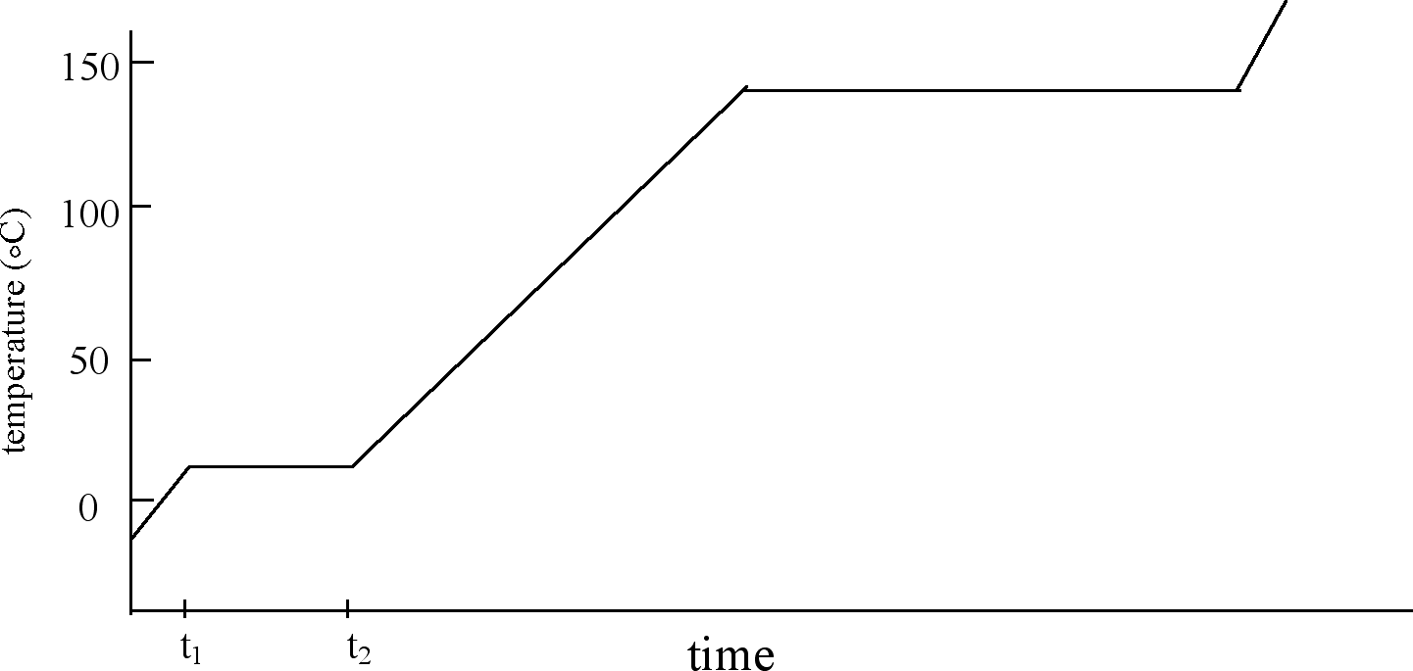 |  |  | 6
 | a What is the approximate boiling point of the substance?  b Indicate on the graph one time when the kinetic energy of the substance is changing but its potential energy is remaining approximately constant.  c During times t₁ to t₂, despite the substance being heated, its temperature is remaining constant. Explain this observation.  d Would you expect the substance being heated to be tribromomethane (CHBr₃) or sodium bromide? Explain your reasoning. |  |  | 6
14 | Using the kinetic theory of matter, explain why washing hanging on a clothes line will dry quicker on a hot day than on a cold day. |  |  | 2
 | During operation, the pressure in the radiator of a car is considerably higher than atmospheric pressure. Explain why it is dangerous to remove the radiator cap when the engine is still hot. |  |  | 2
 | When gaseous HBr is added to water, the solution formed is a very good conductor of electricity. However, when liquid CH₃OH is added to water, the solution formed does not conduct electricity. Explain these observations. |  |  | 4
 | Describe what you would expect to see when the following pairs of solutions are mixed:  a a solution of cobalt nitrate and a solution of sodium carbonate  b a solution of zinc chloride and a solution of calcium nitrate  c a solution of lead nitrate and a solution of potassium sulfate  d a solution of iron(III) chloride and a solution of sodium hydroxide. |  |  | 4
 | What mass of K₂SO₄ would be contained in 208 mL of 0.910 mol L^{–1} K₂SO₄ solution? |  |  | 2
 | 0.200 moles of solid MgCl₂ are added to a 1.20 L of 1.40 mol L^{–1} NaCl solution.  a Calculate the concentration, in mol L^{–1}, of Cl– ions in the ‘new’ solution.  b What assumptions have been made in this calculation? |  |  | 5
 | The health authorities in Australia recommend the safe level of lead in drinking water to be 0.01 ppm (1 ppm of lead = 1 mg of lead dissolved in 1kg of drinking water). Despite lead and its compounds being very toxic, products used every day, such as car batteries, still contain lead. Lead and many of its compounds are insoluble in water, so it is assumed that very little lead enters the drinking water supply by the dissolution of lead substances. Lead(II) oxide, a compound regarded as insoluble in water, is used to make crystal glassware and as a pottery glaze. The solubility of lead oxide at 25ºC is 0.002 g per 100 g of water. If some water is stored in a bowl of crystal glass, determine whether this water could possibly dissolve sufficient lead oxide to raise the level of lead in the water over the recommended safe level. |  |  | 4

